DAY 1
TASK 1 — Linux IP Investigation
Screenshot:

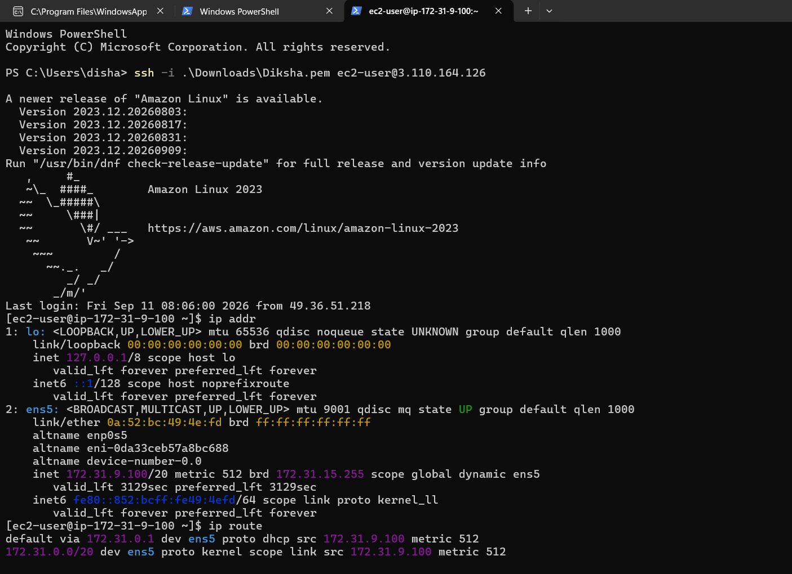
2)Find the system's IP address: ip addr
Output: inet 172.31.7.155/20
3)Identify the network interface being used: ip addr
Output: 2: ens5: <BROADCAST,MULTICAST,UP,LOWER_UP>
4) Find the default gateway: ip route
Output: default via 172.31.0.1 dev ens5
5) Find the DNS information: cat /etc/resolv.conf
Output: nameserver 172.31.0.2
search ap-south-1.compute.internal
6) Display the complete network configuration: ip addr
Output: 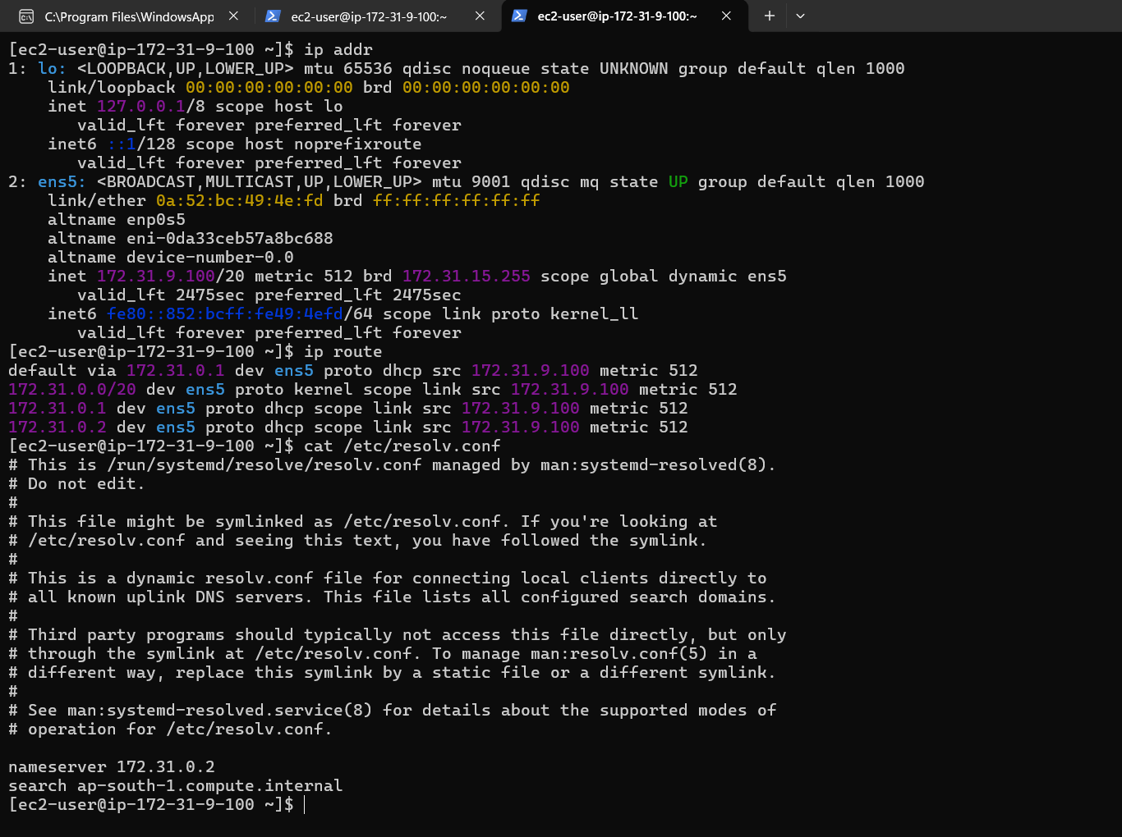

TASK 2 — IPv4 Address Analysis :
- Investigate the IPv4 address assigned to your Linux machine: ip addr
Output: inet 172.31.9.100/20
- Identify the IPv4 address and separate it into its four octets: IPv4 Address: 172.31.9.100
- Identify the value of each octet:
Output: The four octet values are 172, 31, 9, and 100.
- Determine whether the IP is private or public:
Output: IP address 172.31.9.100 is a Private IPv4 address
- Use appropriate Linux networking commands to investigate the network/host information: ip addr
Ip route
cat /etc/resolv.conf

TASK 3 — Dynamic IP Investigation

- Investigate how dynamic IP addressing behaves on your Linux machine: ip addr
Output: 172.31.9.100
- Record the current IP address: ip addr
Output: inet 172.31.9.100/20
- Check the network connection status: ip addr
Output: ens5: <BROADCAST,MULTICAST,UP,LOWER_UP>
- Disconnect and reconnect the network, only if your environment safely allows it:
Output: Not performed because disconnecting the network interface on the remote AWS EC2 server could terminate the SSH connection
- Compare Old and New IP Addresses:
Output: Before disconnect → 172.31.9.100
After reconnect → 172.31.9.100
- Record whether the IP changed:
Output: No changed

TASK 4 — Cloud Linux Server & IP

1)Create a AWS EC2 Linux instance:
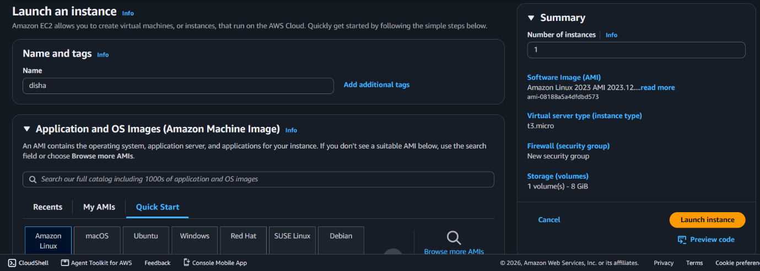
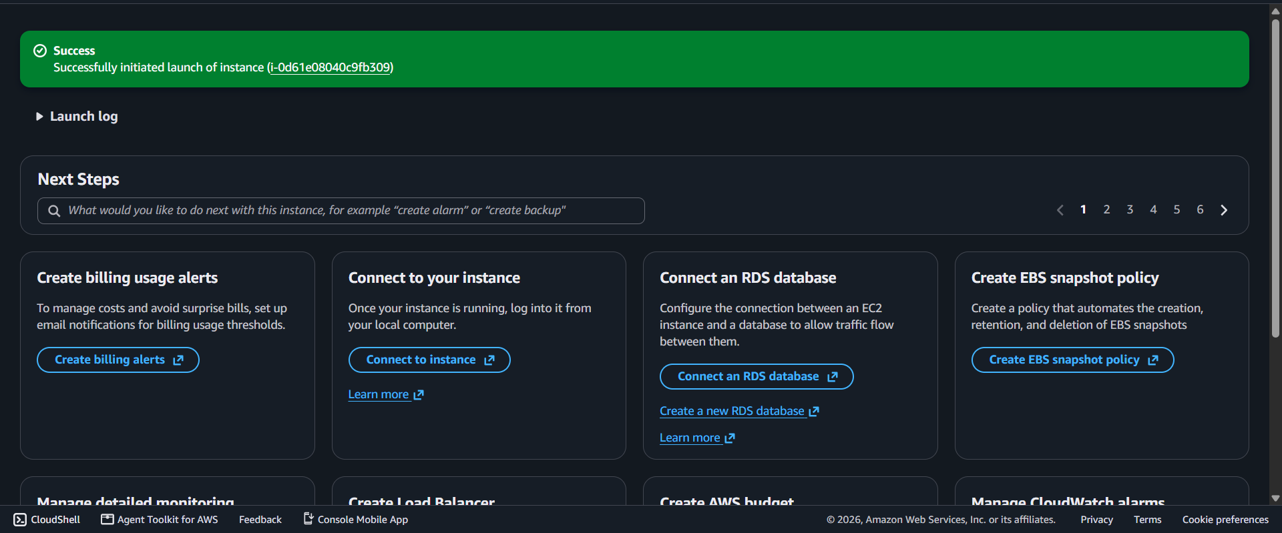
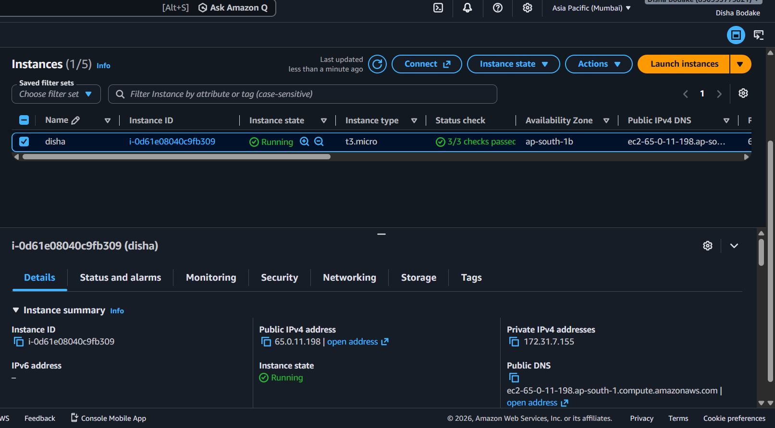
Connect to the VM using SSH: ssh -i ".\Downloads\disha.pem" ec2-user@65.0.11.198
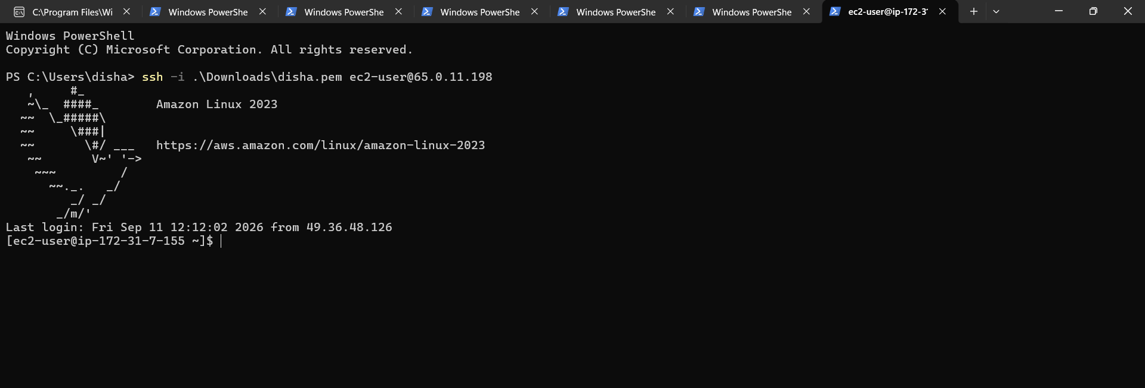
Find its private IP from inside Linux: ip addr
Output: inet 172.31.7.155/20
Find its public IP: Public IPv4 Address: 65.0.11.198
Compare the IP information shown in the cloud console with the information shown inside Linux: Public IPv4 Address: 65.0.11.198
- Private IPv4 Address: 172.31.7.155

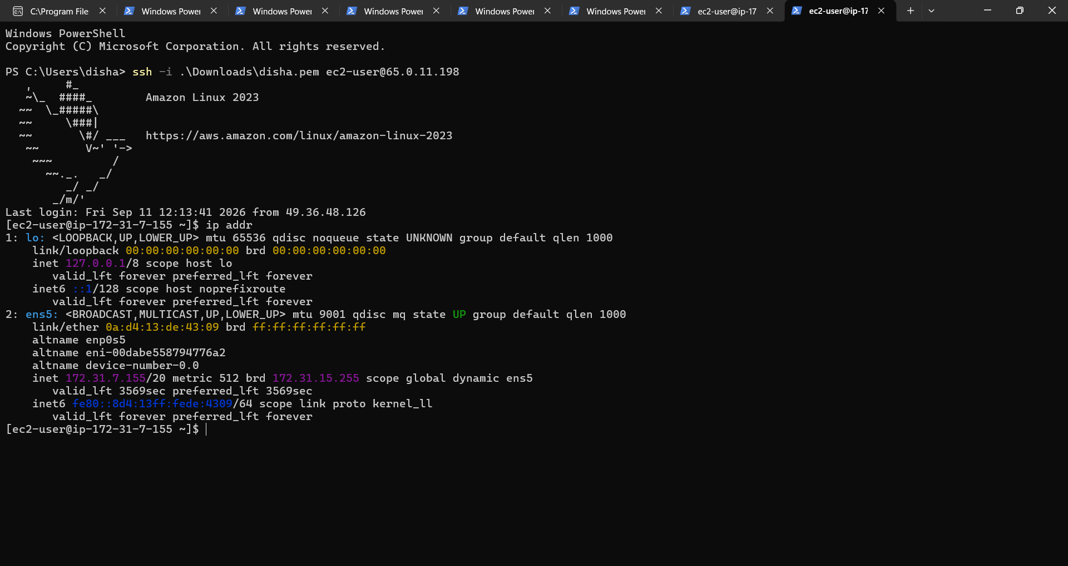

TASK 5 — Cloud Network Troubleshooting
